**Assignment-7**

VIEWs:

1. Create a view D_10EMP containing details of employees in department 10.

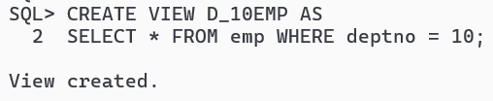

2. Create a view Dept_Summary containing Dname, MINSal, MAXSal, AVGSal.

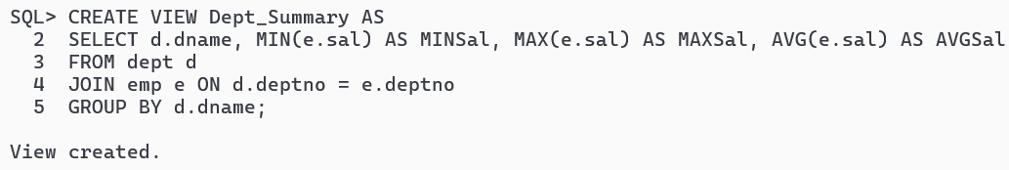

3. Create a view Emp_Data which would validate entry of any INSERT/ UPDATE command so that Sal figure  
would be between 10000 to 20000 and MGR would have to be a valid Empno, and Deptno must exists on Dept  
table.

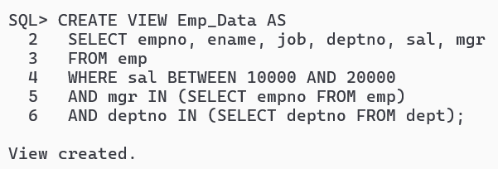

4. Create a view which restricts data access to a valid employee’s own details on the Emp table and access time to office hours (09-17 and MON- SAT).

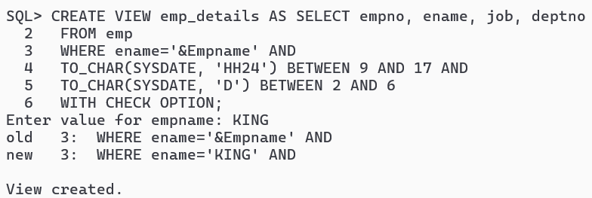

5. Create a view EMPLOYEES from emp table which contains empno, ename, job, depy and validate the deptno.  
that must be in Dept table.

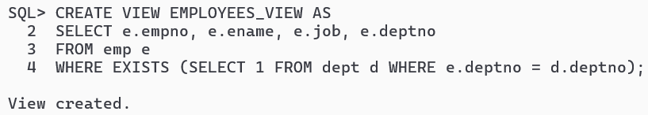

6. Create a READ only view EMP_READ from emp table which contains job, minsal, maxsal.

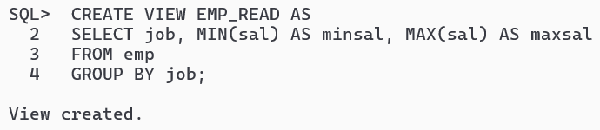

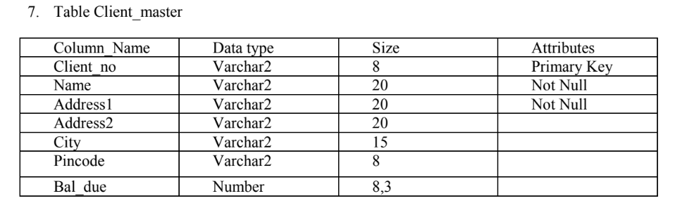

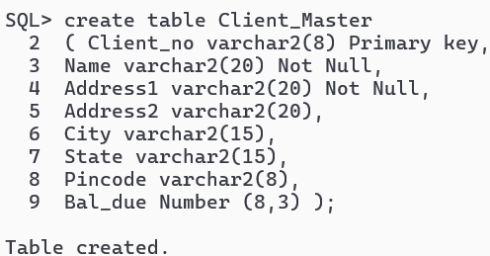

A. Create a view vw_clent_master using Client_no,Name,Address1 and Bal_due

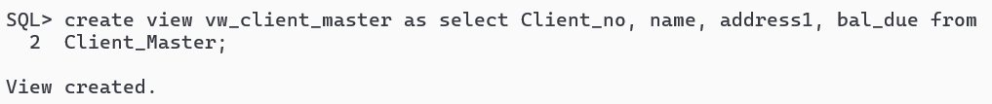

i. Insert at least 3 records to vw_client_master.

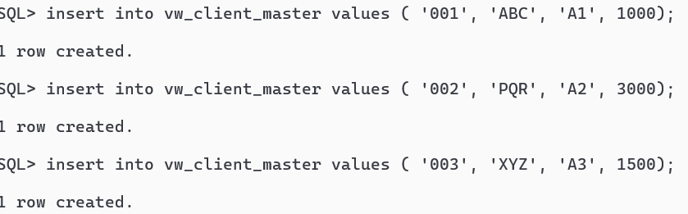

ii. Update a record to vw_client_master.



iii. Delete a record from vw_client_master.

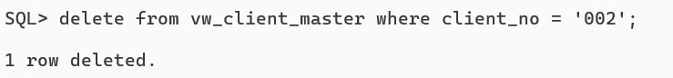

And check that the above operation if the base table is affected or not.

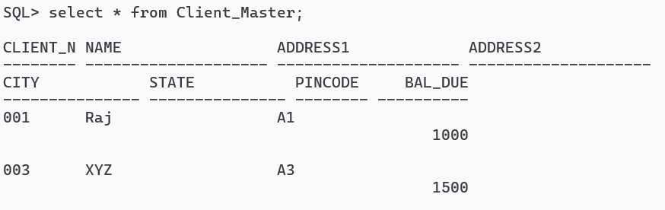

B. Create a view Vw_sales_det using Order_no,Order_date, Product_no, Qty_ordered, and order_status for all  
order which have already marked as ‘Backorder’ .(Using the tables sales_order,sales_order_details).

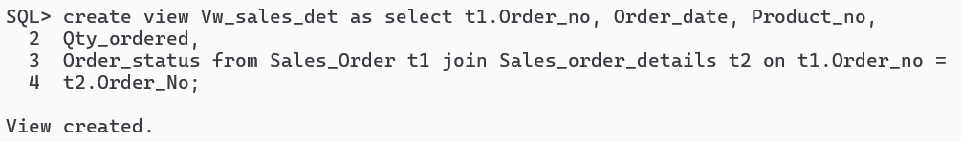

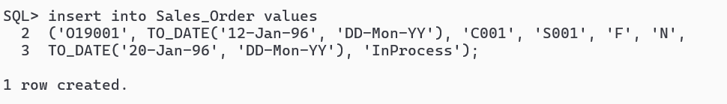

i. Insert a record to vw_sales_det.

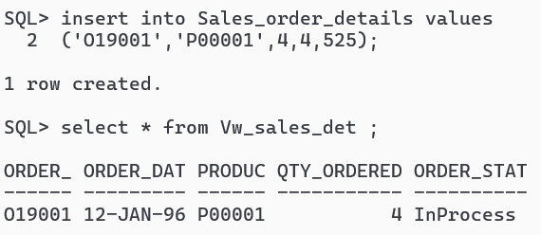  
ii. Update the client_no for a particular order_no.

  
iii. Delete a record.

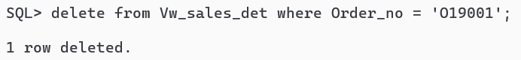  
iv. Remove the views from database.

